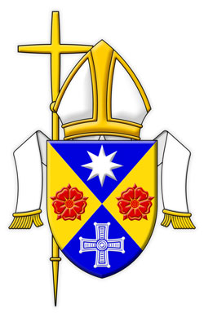
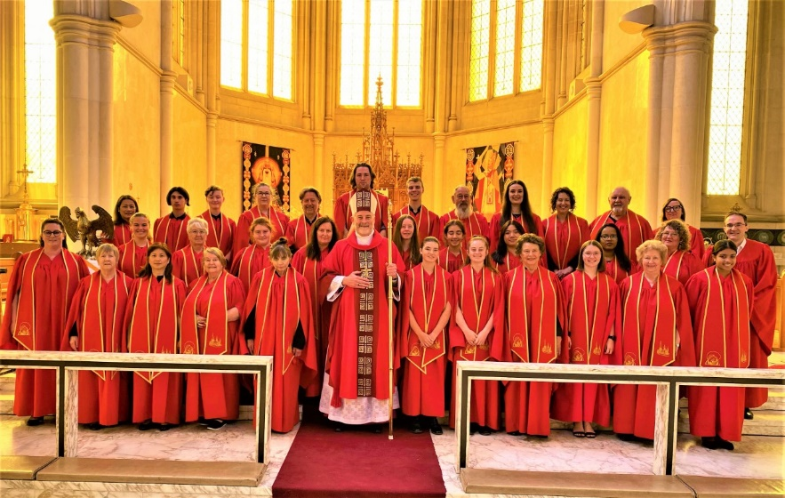

SACRED HEART CATHEDRAL CHOIR SCHOLARSHIPS

The Sacred Heart Cathedral Choir in Bendigo is currently wishing to recruit new members from amongst the students at Catherine McAuley College and Marist College, Bendigo.

The mixed-voice (SATB) Cathedral Choir currently comprises 32 members, approximately half of whom are on scholarship are drawn from amongst Catholic schools in Bendigo.

The scholarships, currently valued at $1,200 per year, offer a wonderful opportunity for students in Catholic Colleges to contribute towards the choral music at Sacred Heart Cathedral.

The choir sings music from the Church’s rich tradition of Gregorian chant and polyphony in Latin and English, plus traditional and contemporary hymnody and psalmody from Catholic and ecumenical sources.

Rehearsals are held in the Cathedral Hall on Thursdays during school terms from 6:30-8pm and on Sundays from 9:45-10:30am in the Cathedral nave, prior to the 11am Mass.

Auditions will be held in the Cathedral Choir Room on Saturday, 19th June 2021 from 10AM

Applicants are required to sing a familiar Christmas Carol or Advance Australia Fair in addition to completing ear tests and a passage of sight-singing.
Sight-singing ability is a distinct advantage.

SACRED HEART CATHEDRAL CHOIR SCHOLARSHIPS
APPLICATION FORM

NAME:

ADDRESS:

PHONE/MOBILE:
EMAIL:

AGE:

BIRTHDAY:
CURRENT SCHOOL:

SCHOOL in 2022:

SACRAMENTS RECEIVED (date, church and priest’s name)
BAPTISM:
RECONCILIATION:
CONFIRMATION:
EUCHARIST:

Please return by to Monday, 14th June 2021

Paul Taylor
Organist & Director of Music
Sacred Heart Cathedral, Bendigo
Mob: 0400 830 929
Email: paul.taylor@sandhurst.catholic.org.au

